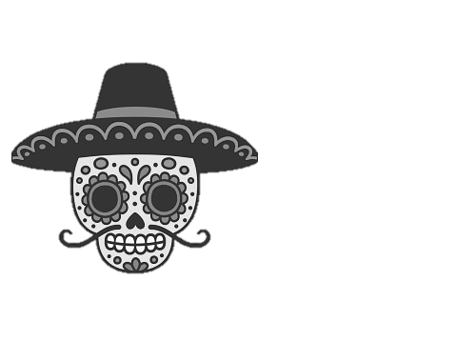

Mexico Lindo

Catering Menu

6225 Highland Rd. Waterford, MI 48327

CALL: (248)-666-3460 FAX: (248)-666-5033

* Corn Taco Bar $11.75 per person

Beef or Chicken, with Lettuce and Cheese, Pico de Gallo & Sour Cream Served with Rice and Beans.

* Soft Shell Taco Bar $12.75 per person

Beef or Chicken, with Lettuce and Cheese, Pico de Gallo & Sour Cream Served with Rice and Beans.

* Fajita Bar $15.25 per person

Meat, onions, green peppers, sour cream, guacamole. Pico de Gallo, Flour or Corn Tortillas. Served with Rice & **Beans**.

**All Bars include Pico de Gallo, Sour Cream, & Salsa**

* House Margarita’s (1 gallon) $69.00 Orig,Strw,Pch,Raz,Wld
* Half Pan of Mex. Lindo Special $77.00 (Approximately 5#) 15 ppl (Ala carte)
* Half Pan of Carne de Puerco $77.00 (Approximately 5#) 15 ppl (Ala carte)
* Half Pan of Seasoned Ground Beef $69.00 (Approximately 5#) 15 ppl
* Half Pan of Shredded Chicken $69.00 (Approximately 5#) 15 ppl
* Burrito Tray $88.00Beef/Chicken (Circle all that apply) 15 Burritos
* Enchilada Tray $88.00 Beef/Chicken (Circle all that apply) 15 Enchiladas
* Half Pan Rice or Beans $29.99 15-20 ppl (As side dish)
* Party Nachos Beef/Chicken $64.99 (Circle choice) 7-10 ppl
* Party Botana w/ Beans $64.99 w/Beef $72.99 7-10 ppl
* Nacho Supreme $75.99 7-10 ppl
* Party Taco Salad $34.99 5-7 ppl
* 50 Chicken Wings $82.00
* Tamales - Pork (Frozen) $28.95/doz Heated $34.95/doz
* Party Sopapilla $21.00 7-10 ppl
* Chips Sm. $3.50 Med. $4.95 LG. $9.50
* Quart of Guacamole $41.00
* Quart of Queso Blanco $41.00

Local Delivery Available. Prices subject to change without notice.

www.mexlindowaterford.com